1. Knowing the elements in the circuit bellow, compute the currents and verify the results with power balance:

$${\text{R}}_{\text{1}}\text{=}\text{10 Ω; }{\text{R}}_{\text{2}}\text{=20 Ω; }{\text{L}}_{\text{2}}\text{=60 mH; }{\text{C}}_{\text{1}}\text{=}\frac{\text{200}}{\text{3}}\text{μ}\text{F; }{\text{C}}_{\text{2}}\text{=200 }\text{μ}\text{F}$$

$$\text{j(t)=}\sqrt{\text{2}}\text{sin}\left(\text{500t+}\frac{\text{π}}{\text{2}}\right)\text{[A]}\text{; }{\text{u}}_{\text{e}}\text{=20}\text{sin}\left(\text{500t+}\frac{\text{π}}{\text{4}}\right)\text{[V].}$$

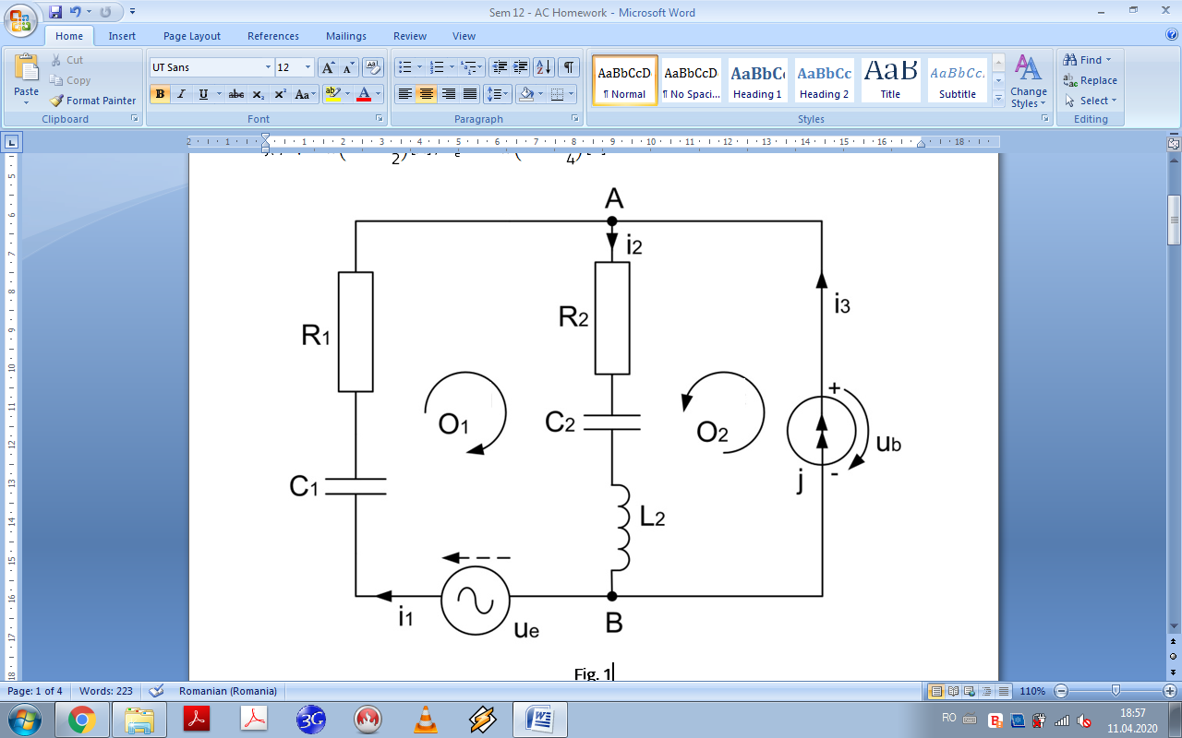

**Fig. 1**

**Results:**

$${\text{i}}_{\text{1}}\text{=}\sqrt{\text{2}}\text{ sin}{\text{(500}\text{t) [A]; }{\text{i}}_{\text{2}}\text{=2}\text{ sin}\left(\text{500t}\text{+}\frac{\text{π}}{\text{4}}\right)\text{ [A]; }}$$

$${\text{i}}_{\text{3}}\text{=}\sqrt{\text{2}}\text{ sin}\left(\text{500}\text{t+}\frac{\text{π}}{\text{2}}\right)\text{ [A];}\text{=}{\text{P}}_{\text{Z}}\text{=50 W; }{\text{Q}}_{\text{G}}\text{=}{\text{Q}}_{\text{Z}}\text{=10 VAr.}$$

**2**. Knowing the elements from the circuit bellow, determine the currents and verify the results with power balance.

$${\text{R}}_{\text{1}}\text{=}\text{2 Ω; }{\text{R}}_{\text{2}}\text{=1 Ω; }{\text{L}}_{\text{1}}\text{=}\frac{\text{30}}{\text{π}}\text{mH; }{\text{L}}_{\text{2}}\text{=}{\text{L}}_{\text{12}}\text{=}\frac{\text{10}}{\text{π}}\text{mH;C=}\frac{\text{10}}{\text{π}}\text{ mF; f=50 Hz; }$$

$${\text{u}}_{\text{e}\text{1}}\text{=16}\text{sin}\left(\text{ω}\text{t+}\frac{\text{π}}{\text{4}}\right)\text{[V]}{\text{; }\text{u}}_{\text{e}\text{2}}\text{=4}\sqrt{\text{2}}\text{sin}\left(\text{ω}\text{t-}\text{π}\right)\text{[V]}\text{.}$$

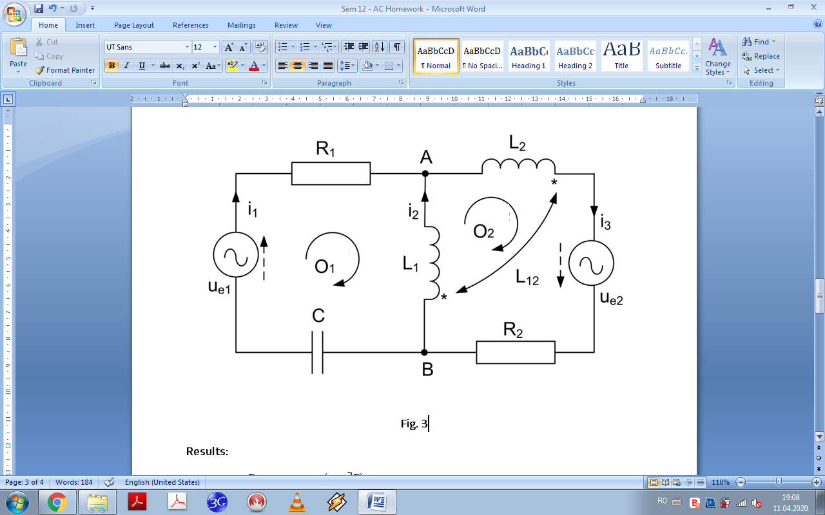

**Fig. 2**

**Results:**

$${\text{i}}_{\text{1}}\text{=}\text{4 sin}{\text{(}\text{ω}\text{t+}\frac{\text{π}}{\text{4}}\text{) [A]; }{\text{i}}_{\text{2}}\text{=4}\text{ sin}\left(\text{ω}\text{t}\text{+}\frac{\text{3π}}{\text{4}}\right)\text{ [A]; }}$$

$${\text{i}}_{\text{3}}\text{=}\text{4}\sqrt{\text{2}}\text{ sin}\left(\text{ω}\text{t+}\frac{\text{π}}{\text{2}}\right)\text{ [A]; }{\text{P}}_{\text{G}}\text{=}{\text{P}}_{\text{Z}}\text{=32 W; }{\text{Q}}_{\text{G}}\text{=}{\text{Q}}_{\text{Z}}\text{=16 VAr.}$$

**3.**. Knowing the elements from figure 4, determine the currents and verify the results with power balance.

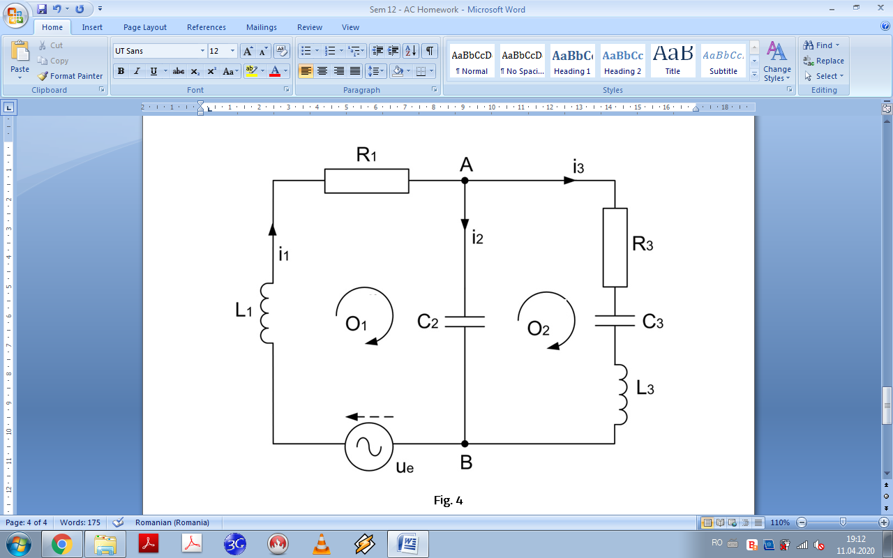

**Fig. 3**

$${\text{R}}_{\text{1}}\text{=}{\text{R}}_{\text{3}}\text{=}\text{ω}{\text{L}}_{\text{1}}\text{=}\frac{\text{1}}{\text{ω}{\text{C}}_{\text{2}}}\text{=}\frac{\text{1}}{\text{ω}{\text{C}}_{\text{3}}}\text{=10 Ω; }\text{ω}{\text{L}}_{\text{3}}\text{=20 Ω;}{\text{u}}_{\text{e}}{\text{=220}\sqrt{\text{2}}\text{sin}\left(\text{ω}\text{t}\right)\text{[V]}\text{.}}$$

**Results:**

$${\text{i}}_{\text{1}}\text{=}\text{11}\sqrt{\text{2}}\text{ sin}{\text{(}\text{ω}\text{t) [A]; }{\text{i}}_{\text{2}}\text{=22}\text{ sin}\left(\text{ω}\text{t}\text{+}\frac{\text{π}}{\text{4}}\right)\text{ [A]; }}$$

$${\text{i}}_{\text{3}}\text{=}\text{11}\sqrt{\text{2}}\text{ sin}\left(\text{ω}\text{t-}\frac{\text{π}}{\text{2}}\right)\text{ [A]; }{\text{P}}_{\text{G}}\text{=}{\text{P}}_{\text{Z}}\text{=2420 W; }{\text{Q}}_{\text{G}}\text{=}{\text{Q}}_{\text{Z}}\text{=0 VAr.}$$